A Technical Seminar Report on

**AIRCRAFT GPS TRACKING**

Submitted to

**JAWAHARLAL NEHRU TECHNOLOGICAL UNIVERSITY**

**HYDERABAD**

In partial fulfilment of the requirement for the award of degree of

**BACHELOR OF TECHNOLOGY**

**IN**

**COMPUTER SCIENCE AND ENGINEERING**

**BY**

**VANAMALA NAVYA**

(18RA1A0527)



**DEPARTMENT OF COMPUTER SCIENCE AND ENGINEERING**

**KOMMURI PRATAP REDDY INSTITUTE OF TECHNOLOGY**

(Affiliated to **JNTUH**, Ghanpur(V), Ghatkesar(M), Medchal(D)-500088)

2018-2022

**ABSTRACT**

GPS aircraft tracking is a means of tracking the position of an aircraft fitted with a GPS receiver. By communication with GPS satellites, detailed real-time data on flight variables can be passed to a server on the ground. This server stores the flight data, which can then be transmitted via telecommunications networks to organizations wishing to interpret it. **INTRODUCTION**

The Global Positioning System (GPS), is a satellite based radio navigation system owned by the United States of Government and operated by the United Space Force.

GPS elements

Three segments :-Space segmentControl SegmentUser segment

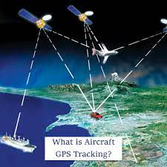

**Space segment**

space segment of an artificial satellite system is one of its three operational components. It comprises or satellite constellation and the uplink and downlink satellite links.

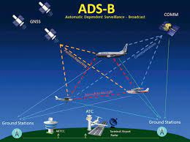

**Control segment**

Combination of a master control station,12ground antennas and 16 monitoring stations responsible for the proper functioning of all the operation of GPS such has changing unhealthy satellite with a healthy one.

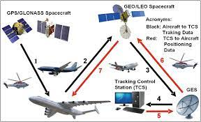

**User segment**

User segmentation is a process of separating into distinct groups or segments, based on shared characteristics, a company might segment users based on language preferences, product version, geographical region and user person.



**HOW IT WORKS**

* Each satellites broadcast radio signals with their location,time and also rebroadcast those signals which are sent by different aircrafts as well as other devices.
* GPS receivers receives radio signals,and used these data to calculate its distance from at least four satellites.
* GPS tracking unit is also known as monitoring system.
* GPS tracking is a navigation device that can be kept in vehicles, animals and even in human beings and with the help of the tool, positions and locations of the things in which it is held can be checked.

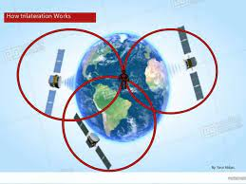

**Technology Management**

* There are 2000 satellites in the space launched by different countries are being properly managed.
* GPS satellites are working in their harmomy in their orbits and unhealthy satellites are being changed with healthy one’s.
* Technology from golden satellites to private planes are managed in admirable way.

**Advantages**

* GPS is extremely easy to navigate because it tells you to direction for every turns you’re taking otherwise you need to fancy reach to your destination.
* GPS works altogether weather so you would like to not worry of climate as in other navigating devices.
* GPS costs you very low as compared other navigation systems.
* Most attraction of this technique is its100% coverage on earth.It also helps you to look nearby restaurants, hotels and gas stations and is extremely useful for a replacement place.
* This is the simplest navigating system in water as in larger water bodies we are often misled thanks to lack of proper directions.
* Enhanced safety of flight thriogh out the region.

**Disadvantages**

* Sometimes GPS may fail thanks to certain reasons and therein case you would like to hold a backup map and directions.
* If you’re using GPS on A battery operated device, there could also be A battery failure and you’ll need a external power supply which isn’t always possible.
* GPS chip is hungry for power which drains battery in 8 to 12 hours. this needs replacement or recharge of battery quite frequently.
* GPS doesn’t penetrate solid walls or structures. it’s also suffering from large constructions or structures.

**Applications**

* Accurate real-time data provided by GPS aircraft tracking may be offered to air traffic control using ADS-B technology.
* This can safely reduce airspace separation of aircraft.
* GPS aircraft tracking also enables airlines to track their fleet of aircraft over the ACARS system and allows aircraft to be more easily located in the event of an accident.

**Conclusion**

The data is processed to gather "OOOI" information about movements within the airport and to compute flight time. Finally, GPS aircraft tracking permits a flight school to track a trainee pilot and debrief his/her flight path afterwards.

**THANKYOU**